**COSC2543 Mobile Application Development**

**Assignment 2**

**Android Application Proposal**

|  |  |
| --- | --- |
| Semester | 12B |
| Student 1 (ID & Name) | S3342133 Phan Thanh San |
| Student 2 (ID & Name) | S3296761 Dinh Tuan Vu |

* **Executive Summary**

The android application will be a cook book application which shows recipes from many kinds of food. The application also has the search feature which allows the user to look for a certain recipes they need. The application will be developed to an enterprise application in which extends feature of the app can only be bought through application provider.

* **Application requirements**

Android Version: 2.2 FROYO

Screen size: 3.7 inch

CPU: 200 MHz

Ram: 32MB

Memory: 32 MB

* **Application’s functionalities.**

Function A: Pagination

The application allows the user to change from one page (recipes page) to another one but a “simple” view flipper.

Function B: Search

A search bar will be display at the menu page, which will allows the user to look for the recipes they want.

There’s a menu display type of the dish for user to choose.

Function C: Top Recipes

The software allows user to look at top 5 most rated recipes every month. If they want to get the recipes, they have to pay through service provider.

Function D: Update

The software will update free recipes every month.

* **Screen Design and Information Flow using** <http://www.droiddraw.org/> **or paper’s sketch.**

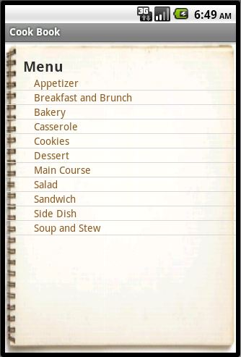

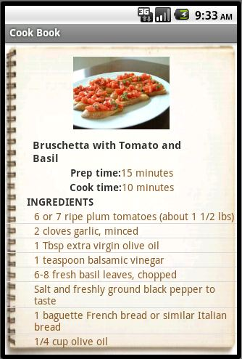A**pplied Areas**

* + Google Map API

At the below of each recipes, a list of restaurant address link will be shown in case user want to check the location of those restaurant.

* + Music Player service

None

* + Location API

None

* + Content Providers

None

* + Widgets

Base on rating by user on recipes, a list of most wanted recipes will be display.

* + SQLite DB

A database will be established to store rating and recipes.

* + Network Services

Connect to network will send request to database, download recipes and update new recipes.

* + Telephone handling

None

* + Search Manager

None

*PS: This proposal includes 2 copies: 1 for student, 1 for lecturer*

Student Signature Lecturer Signature